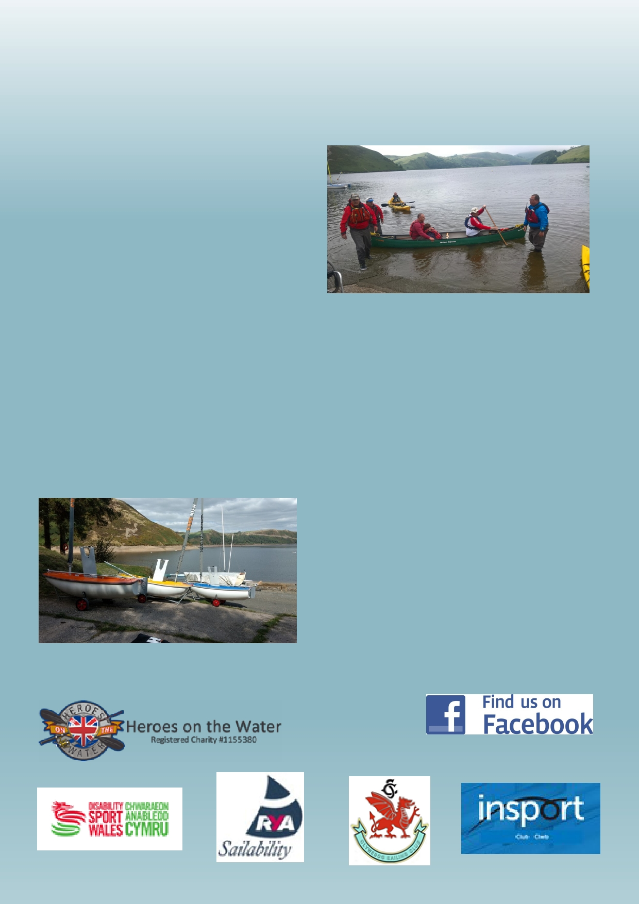
Clywedog Sailing Club Sailability
& Kayaking Day

Sat June 22nd 2019
10.30am – 4.00pm

near Llanidloes, in Mid Wales.
5mls from Llanidloes, follow signs to
Dam then for Sailing Club

Sailability boats and sit on Kayaks will be available
throughout the day for participants to try out, together with the club's Access and Sunbird dinghies.

Please bring spare clothing/towels etc. in case of wet weather. Drinks and snacks available

of
Enquiries
Keith Rollinson - 01686 640305
Beverley Tucker - 01874 612034

keith@rollinson.me
beverley.tucker@powys.gov.uk

